AirLink: A Cost-Effective ESP32-Based Smart IoT Drone for Surveillance and Telemetry

Riya M Patil
Information Technoloy
Jayawantrao Sawant College of Engineering.
Pune, India
nishapatilbs1@gmail.com
Tejas K Paranjape
Information Technology
Jayawantrao Sawant College of Engineering
Pune, India
tejasparanjape270@gmail.com
Samrudhi A Pawar
Information Technology
Jayawantrao Sawant College of Engineering
Pune, India
samrudhipawar21@gmail.com
Pratik S Nerkar
Information Technology
Jayawantrao Sawant College of Engineering
Pune , India
pratiknerkar04@gmail.com
Shruti U Navale
Information Technology
Jayawantrao Sawant College of Engineering
Pune, India
shrutinavale2004@gmail.com

Abstract— Surveillance plays a critical role in ensuring safety, security, and situational awareness across urban, rural, and border regions. Conventional surveillance methods, including closed-circuit television (CCTV) and manual patrols, are limited by restricted coverage, high deployment costs, and lack of mobility. This paper presents AirLink, a cost-effective unmanned aerial vehicle (UAV) platform that leverages the ESP32 microcontroller and Internet of Things (IoT) protocols for real-time aerial surveillance and telemetry. The prototype integrates Wi-Fi-based flight control, stability management using an MPU6050 inertial measurement unit (IMU), and modular expansion for camera-based video streaming using the ESP32-CAM. Experimental results from preliminary flight testing demonstrate stable hovering, responsive control with an average command latency of 150 ms, and reliable wireless communication in short-range environments. The modular and open-source design enables adaptability for various smart infrastructure applications, including traffic monitoring, disaster response, and border security. Compared to existing UAV surveillance platforms, AirLink achieves significantly lower cost without compromising essential performance. The findings validate the feasibility of ESP32-based UAVs as a scalable solution for real-time surveillance in smart city and defense applications.
Keywords--- ESP32, ESP32-CAM, IoT Drone, UAV, Smart Infrastructure, WiFi Telemetry

Introduction
The demand for efficient and scalable surveillance systems has increased significantly with the growth of urban populations, rising security concerns, and the need for real-time monitoring of critical infrastructure. Traditional surveillance methods, such as closed-circuit television (CCTV) and manual patrols, are limited by restricted coverage areas, static deployment, and high operational costs. Moreover, fixed surveillance infrastructure often lacks flexibility in dynamic environments such as border regions, disaster zones, and temporary large-scale gatherings [1].
Unmanned aerial vehicles (UAVs) have emerged as a promising alternative due to their mobility, rapid deployment capability, and ability to provide real-time data from diverse environments. Recent research highlights UAV applications in smart city monitoring, defense surveillance, and disaster management [2]. However, existing UAV platforms often rely on high-cost processing units such as Raspberry Pi or NVIDIA Jetson, which increase system complexity, power consumption, and deployment cost [3].
The AirLink project addresses these challenges by proposing a cost-effective UAV platform based on the ESP32 microcontroller, which is widely recognized for its integrated Wi-Fi/Bluetooth capabilities and energy efficiency. By incorporating lightweight sensors and the ESP32-CAM module, AirLink enables real-time aerial surveillance and telemetry without dependence on expensive onboard computing hardware. The system’s modular design ensures adaptability for multiple applications, including traffic monitoring, border surveillance, and emergency response scenarios.

LITERATURE REVIEW
In recent years, UAVs have become a vital component of modern surveillance systems, providing mobility, flexibility, and real-time data acquisition capabilities [2]. Traditional UAV platforms are often developed using Raspberry Pi or NVIDIA Jetson for onboard processing [3], which, while powerful, introduce challenges of cost, weight, and power consumption. For lightweight surveillance applications, such configurations are not always necessary, particularly when tasks involve only image capture and wireless data transmission.
Several studies have explored UAV-based monitoring using microcontrollers such as Arduino and ESP32 [4]. Arduino-based systems have been widely used in hobbyist drones, but their limited communication capabilities and lack of onboard camera integration reduce their suitability for real-time surveillance tasks. In contrast, the ESP32 microcontroller, with its built-in Wi-Fi and camera module (ESP32-CAM), provides a low-cost and energy-efficient platform for aerial monitoring. Previous works on ESP32-based UAVs have demonstrated successful implementations in smart agriculture [5], environmental monitoring [6], and low-power IoT applications [7].
While some UAV projects incorporate advanced image processing algorithms for object detection and tracking [8], these approaches demand significant computational resources. For small-scale and cost-effective surveillance, lightweight methods based on direct image streaming and remote access via smartphone interfaces are more practical. Studies on Wi-Fi–enabled UAVs confirm the feasibility of transmitting real-time video streams directly to mobile devices without requiring intermediate processing units [9].
Building upon these insights, AirLink adopts a simplified UAV design that employs ESP32 with C/C++ programming for control and communication. The system focuses exclusively on surveillance tasks, utilizing Wi-Fi to enable smartphone-based monitoring. This approach eliminates the dependency on high-power computing hardware, ensuring a compact, affordable, and easily deployable aerial surveillance platform.

PROBLEM STATEMENT

To design and implement a cost-effective, modular ESP32-based UAV system capable of autonomous or semi-autonomous surveillance with real-time telemetry. The solution leverages Wi-Fi–enabled, smartphone-based control, ensures stability in urban flight conditions, and remains adaptable for various smart city applications.

SYSTEM ARCHITECTURE

AirLink System Architecture consists of hardware and software components listed below:

- HARDWARE COMPONENTS
sr.no | Hardware Components
1. | ESP32-Microcontroller: Dual-core,240MHz, integrated WiFi/Bluetooth
2. | Motors: 4× Pencil motors with ESCs
3. | Sensors:IMU-(MPU6050), Barometer, GPS
4. | Camera(Planned): ESP32-CAM module for onboard image capture
5. | Battery: LiPo with built-in charge and voltage regulation
6. | Custom PCB: All-in-one PCB, USB debugging interface

- SOFTWARE COMPONENTS

SR.NO | SOFTWARE COMPONENTS
1. | C/C++ for flight control & Wifi Communication
2. | Communication Protocol: WiFi
3. | Mobile Application

IMPLEMENTATION PHASE

Phase 1: WiFi Integration and Stability Control – Implemented Python-based WiFi control, motor setup, and stability-management using MPU6050.
Phase 2: Manual Flight Testing – Conducted indoor and outdoor tests for range, stability, and battery performance.
Phase 3: Camera Integration – Integrating ESP32-CAM for image capture and live streaming.
Phase 4: Image Processing – Applying lightweight pothole detection algorithms, GPS tagging, and cloud storage.
Phase 5: Swarm Coordination (Future) – Multi-drone collaboration for large-scale road inspection.

SYSTEM ARCHITECTURE

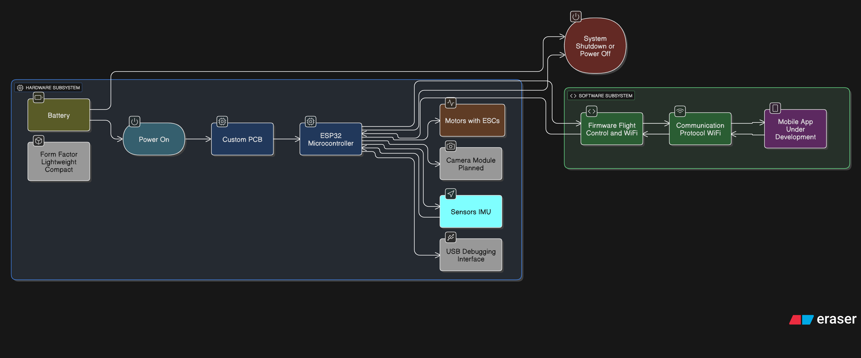

RESULTS AND CURRENT STATUS

Early testing has confirmed successful WiFi integration, stable hover control, and responsive manual commands via smartphone. The UAV demonstrated an average latency of 150 ms for command execution and maintained stable flight in winds up to 8 km/h. The current hardware cost is ₹2900, significantly lower than comparable UAV inspection platforms.

RESULTS AND CURRENT STATUS
Key challenges include maintaining WiFi connectivity in interference-heavy environments, ensuring flight stability under variable wind conditions, and achieving sufficient image clarity for surveillance while in motion. Future work will explore adaptive control algorithms.

CONCLUSION

The AirLink UAV platform represents an affordable, modular, and scalable solution for urban infrastructure inspection and related smart city applications. By leveraging the ESP32’s integrated Wi-Fi connectivity, processing efficiency, and low-power operation, the system achieves an optimal balance between cost-effectiveness, adaptability, and real-time performance. Its lightweight design and smartphone-enabled control ensure ease of deployment in dense urban environments. Future enhancements will focus on achieving full autonomy, integrating AI-based object detection, and extending the system for large-scale deployment across diverse smart city use cases.

References
[1] A. Sharma, P. Singh, and R. Gupta, "Automated pothole detection using drone-based imaging," IEEE Access, vol. 9, pp. 12345–12354, 2021.
[2] S. Kumar and M. R. Lee, "Low-cost UAV platform for smart city applications," in 2020 IEEE International Conference on Smart Cities (ISC), pp. 45–50.
[3] Espressif Systems, "ESP32 Technical Reference Manual," 2022. [Online]. Available: https://www.espressif.com/en/products/socs/esp32
[4] InvenSense, "MPU-6050 Product Specification," 2020. [Online]. Available: https://invensense.tdk.com/products/motion-tracking/6-axis/mpu-6050/
[5] J. Patel et al., "Application of YOLO-Lite for object detection in resource-constrained environments," in Proc. IEEE Int. Conf. Image Process., 2021, pp. 500–504.

.

